MUTAMBA ABUDI 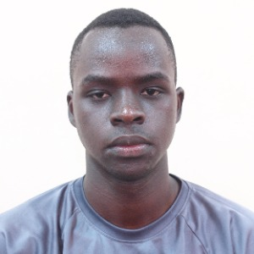

Nationality: Ugandan

Nsambya-Uganda

Mobile: (+256) 7O6929732

Email:mutambaabudi@gmail.com

**PROFILE:**

“All I do is share my passion so that I influence someone’s life.”

**CORE VALUES:**

* Patience in terms of respecting time.
* Integrity in terms of what’s right at all times.
* Proactive so that am deliberate.

**EXPERIENCE**

* Shine Africa.

In February 2020 I got the opportunity to learn how to use WordPress in building website, now am using the skills gained from Shine Africa in assisting in their projects like theugandatrips.com, Rubonicommunity.com building my experience in website development.

* Imagination Circle Ltd**.**(www.imaginationcircle.org)

In June 2019 to date, I got a chance to be invited to assist children and youth find, grow and learn to use their talents as a teacher which has built my experience as a dance teacher. Now am working as the IT expert for Imagination Circle.

* Breakdance Project Uganda **(BPU)**

June 2010, I joined BPU and started to volunteer to teach and share me breakdance skills through the weekly breakdance sessions of over 50 people as a way of empowering my community through hip-hop. Dance and creative facilitation.

**Familiar**

* C
* JAVA
* HTML
* SQL
* CCNA v1
* Huawei Networking

**EDUCATION BACKGROUND**

* Solver Program Scholarship.

April 2020 I got the opportunity to join the solver program scholarship organized by Ablestate Creatives limited to help me use the skills gained to solve world problems that make our world a better place.

* Makerere University.

I joined Makerere University in August 20929 to pursue a bachelor of science in computer science improving my knowledge in the world of technology and programming which gave me urge to look out for opportunities thus joining the solver program, scholarship.

* ESOM school of music

I joined Esom school of music in February 2019 to November 2019 to understand sound setup and sound management to help out in dance events to have good sound. I was awarded a sound engineering certificated at the end of the course

**CERTIFICATES**

* Boys mentorship Program

I was invited to facilitate a one week boys camp as an instructor to build men traits in young boys adding onto the boy child and awarded a participation certificate.

* Sound Engineering

. I was awarded a sound engineering certificate at the end of the course at ESOM school of music in setup, cable wiring, audio production basics in sound.

* St Mary’s boarding secondary school kitende

I was awarded a certificate of merit after holding dormitory superintendent office for 1 year SMASK.

* Glow and Build Peace Corps Camp

I completed a two weeks training in personal development in Bushenyi so as to build my leadership skills and awarded a certificate of completion.

* Brave Festival

I got an opportunity to represented Uganda through Breakdance Project Uganda in an international culture exchange using dance in Poland Warsaw which exposed me to various cultures.

.